CFG 2022
CFG Shortlist Result | 09 May 2022
CodeForGood Bootcamps (GitHub, Office Hours, Presentation Skills) - Zoom | 24-26 May 2022 (1 hr sessions every day)
Slack Invites | 25 May 2022
BeMyApp Registration Invites | 08 June 2022
Team Alignments | 08 June 2022
JPMC CodeForGood Hackathon | 11 - 12 June 2022

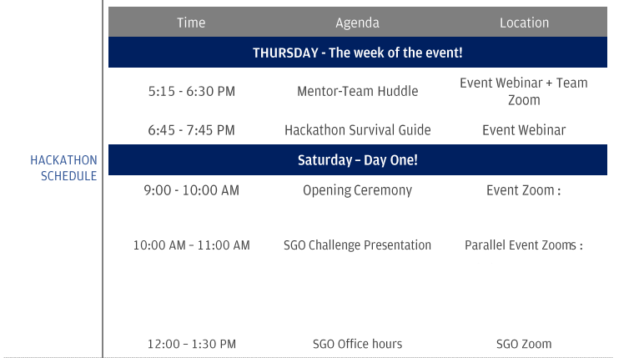
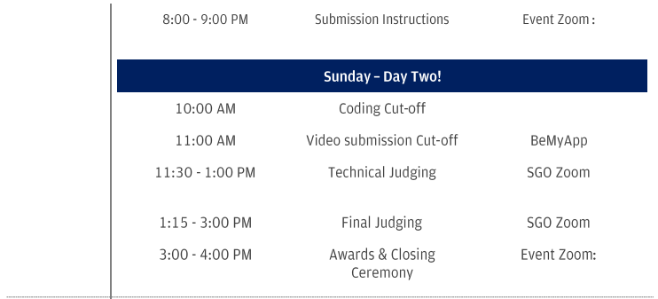

Finding Team Alignments

Always be active on your BeMyApp website. Keep in mind there are 2 websites, cfg.bemyapp.com and c4g.bemyapp.com based on your team positioning.

Our team alignments were posted on 8 June 2022, in the evening.

I quickly started looking for all these people on Linkedin and Slack. I created a separate Slack workspace and invited them to it.

BTW, it’s possible to have more than one student from the same institute, in my case I had one other student from VESIT. I’ve also seen some teams that have 3-4 students from the same institute.

We also created a WhatsApp group. This is not necessary and not recommended for 2 reasons - firstly, your mentors are not allowed to connect with you via any media except the assigned Zoom meeting and Slack; secondly, the conversations that you have on WhatsApp are not credible in context to the event, i.e. if you witness something untoward in the group, the messages will not hold much value in your report if you make one.

We were a team of 8 people, but we ended up with only 4 people ready to work for the event due to different circumstances.

Mentor-Team Huddle

We join our team-assigned Zoom meeting where our mentors are the hosts and they allow us in.

Since I already had a word with my teammates on WhatsApp and had a meeting with them on Google Meet earlier that day, we were pretty comfortable with each other.

In the meeting, we introduced ourselves and talked about our strengths, different technologies we’ve worked on, etc. It is a pretty casual conversation, nothing too serious.

We then joined the hackathon-survival guide workshop, where the organizers talked about things we need to know and remember throughout the event.

Our Tech Stack decided was:
Next.js Frontend
Strapi Backend (for any web-based solution)
Flask/Django Backend (if AI/ML is involved)

Day 1 of the Event

It’s good to have at least 8 hours of sleep before the day of the event since you’re going to be sleep deprived for at least 26-30 hours straight.

After waking up at about 7 AM, I decided to review the boilerplate code I had set up for the Next.js project, already set up with API routes for authentication.

The problem statements (in PDF format) were released at 7:40 AM.

Pro tip: Do not delve too deeply into these statements, this is just a written format of what is expected out of us. Naturally, not all of this can be completed in one day.

The Opening Ceremony starts at 9 AM.

At 10 AM, the challenge statements from different SGOs are displayed. The representatives from these SGOs talk about their problems in a video. Focus on THE PROBLEMS they mention. Ignore the challenge statement here for a second.

Sometimes, the SGOs don’t clearly mention what they want, they just keep beating around the bush about what they do and what they aim to achieve, but try to get as much clarity as possible from the video.

You can replay these videos as they’re shared in Google Drive.

At 11 AM, a survey is opened to all teams as they’re asked to share their order of preference. We submitted our form in less than 2 minutes and were assigned the second SGO on our priority list.

The SGO assigned to us was CGAP (Center for Gender and Politics), an organization that functions in South Asia trying to spread awareness about the importance of women in Politics.

From 11 AM to 12:30 PM

We discussed a lot of things in this period, we talked about the different problems faced by the organization and how we can solve them. We talked about assigning different roles to different people. Since we were down to only 4, individual responsibilities were significantly bigger.

We prepared a set of questions to ask the representative from our SGO.

From 12:30 to 1:30 PM

This time is assigned for Office Hours with the SGO representatives so that the students get a better understanding of what the SGO requirements are. We used this time to get a few of our doubts cleared. Akhil Neelam, the representative from CGAP was very supportive and provided us with a clear idea of what he expected us to do.

Post Lunch

We had our tasks divided among us, so we started working post-lunch.

I was working on managing the front end and things around it since I’m very comfortable with Next.js.

I also helped with creating the schema for our database.

Our implementation was to create a markdown blog for CGAP where they could showcase their articles. All of this was dynamic, backed by our Strapi CMS, where people could store their data and upload their articles there directly.
Submission Guidelines | 8 PM

A session was scheduled at 8 PM for explaining the guidelines to submit our project on their BeMyApp platform. It’s a pretty important session, it’s recommended that at least 2 to 3 of your teammates join it.

Night

A lot of people will recommend you at least 3-4 hours of sleep but when you only have 4 people, that’s not a choice you can make.

It’s subjective, if you think you can sleep, wake up in 3-4 hours and get on your feet in a matter of minutes, consider taking that nap. Otherwise, I’d suggest just going through the night.

I did take breaks and took a stroll around the hallway and another room in my house since going out wasn’t an option either, but I was determined not to sleep.

The next morning

Day 2 of the event

At about 8 AM, we were done with our code. This is thanks to the boilerplate code that we had ready and obviously, the work that we did overnight.

We pushed our final changes to the master branch and updated the readme.MD files. The GitHub Repository is locked by 9 AM, the coding cut-off time.

While we were coding, we had at least one or two people working on a small Canva Presentation to explain our approach to the problem.

Video Submission

We recorded ourselves explaining the presentation and then showed the demonstration of our website. The video was supposed to be under 7 minutes, and because of this, we had to speed it up a little bit in the editor.

We submitted the video along with the presentation and other details on the BeMyApp website by 11 AM.

Technical Judging Round

We played this video in front of the judges (you can also directly present your work live) and answered their questions.

This round was pretty standard, the panel only asked simple questions to understand the solution we had made.

Making it to the finals

One thing I did not mention here yet, is our interactions with our mentor. Our mentor was kind, he shared his experiences and talked about how we should ideally approach the solution and how we should answer the panel’s questions.

We also had our sessions(individually) with our mentor, where he asked us about our contributions and our experiences at the event.

Don’t be surprised if your mentors talk about using Java, since that’s what they have been working on. One of my mentors also suggested using SpringBoot.

In the middle of all this, the results for the technical judging round were up. AND WE MADE IT TO THE FINALS!

We all were thrilled with this result. Our mentor appreciated our work and also shared some advice for the final round.

Final Judging Round

I’ve made a lot of presentations in front of judging panels, but this has been, hands down, the best reaction I’ve ever seen from one. They couldn’t stop praising our work, how simple yet efficient it was, how it was scalable, etc.

I believe we got a lot of points for the solution-based approach we followed. We almost knew the result after that reaction.

The Results

The closing ceremony started at 4 PM. The winners were announced for all organizations, one after the other. I was ready with OBS to record the winning moment. My heart stopped beating for a second when CGAP showed up on the screen. And after a 5-second countdown, our team name showed up!

We expressed our happiness and gratitude to each other and our mentor. We all were delighted. I couldn’t stop smiling for the next half an hour.
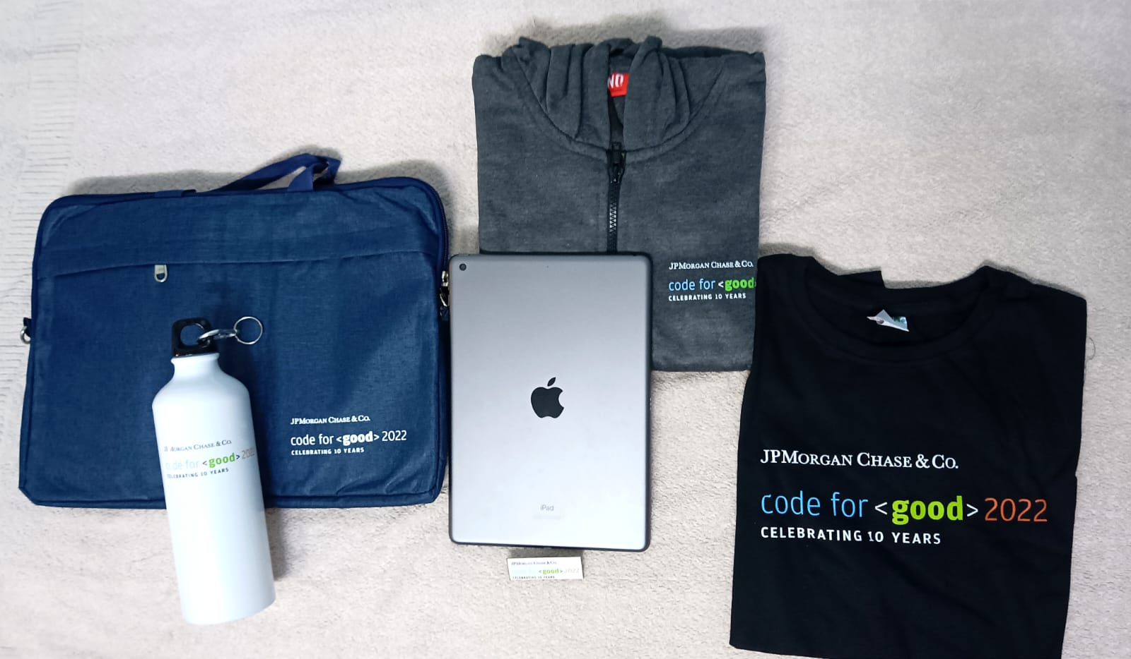
A couple of months later, JPMC shipped an iPad 9th Gen (10.2 in. WiFi 64 GB variant) to my place, for winning the competition. Event goodies like a t-shirt, a hoodie, etc. are sent to all participants.

Thanks for reading about my experience. I hope it helps you out when you participate in CFG, and I also hope that you get to work with your teammates offline at the JP Morgan Chase & Co. campus in Mumbai :)

